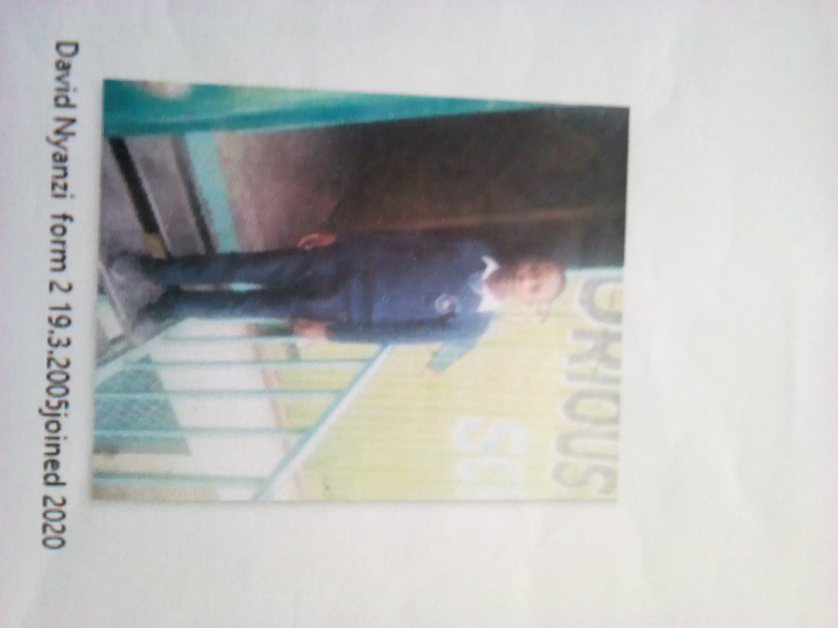

DAVID MWENDWA FORM 2 BORN 2005 JOINED 2020
David 16 years was enrolled in our school when he was 15 years old. David is a need boy was staying with a distance relative who had neglected him. Living in hostilities forced him to seek help from Glorious. After a close look at his situation we resolved to allow him access education. Glorious is his home for a better tomorrow.
Thanks to the Director Mr. Boniface Mangeti who allowed David in school. I am now learning in glorious at least I have a place I call home praying that one day God will help our school have good classes, toilets and enough study materials. Thank you Michell and Brad for your support have really helped many in Mukuru

